**Object Oriented Programming**

**LAB ACTIVITIES (C++)**



Submitted by: **AWAIS SADDIQUI**

Registration No.: **21PWCSE1993** Class Section: **A**

“On my honor, as student of University of Engineering and Technology, I have neither given nor received unauthorized assistance on this academic work.”

Submitted to:

# Engr. Sumayyea Salahuddin

December 16, 2022

**Department of Computer Systems Engineering**

**University of Engineering and Technology, Peshawar**

**ACTIVITY 1.4.1:**

**Output:**

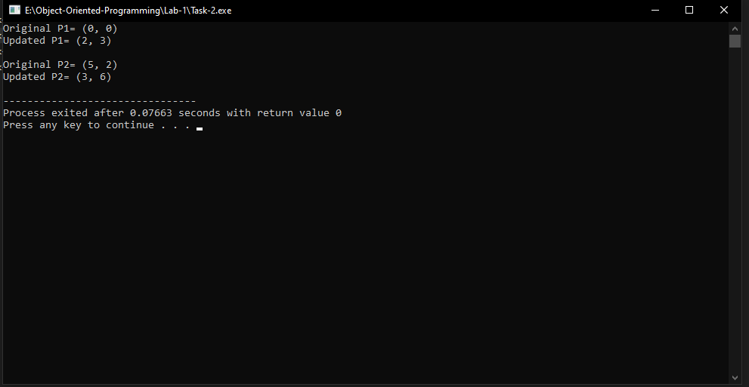

**ACTIVITY 2.4.1:**

**Output:**

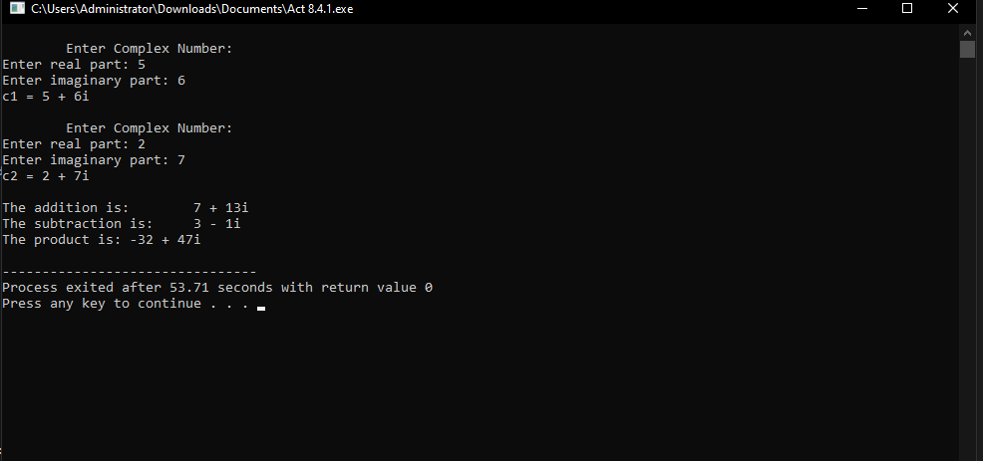

**ACTIVITY 4.5.1:**

**Output:**

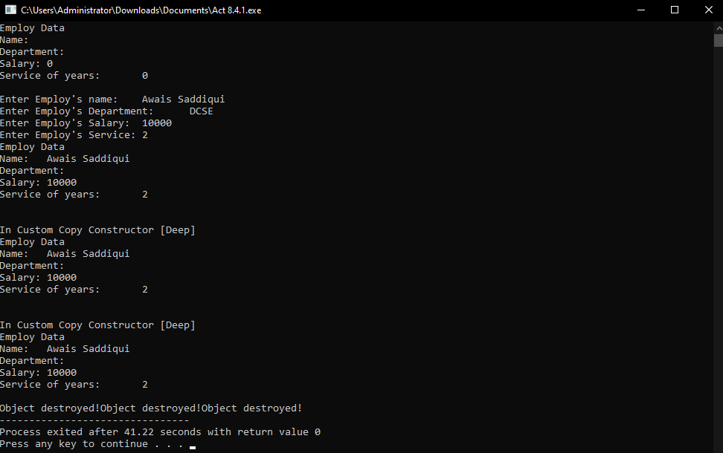

**ACTIVITY 5.4.1:**

**Output:**

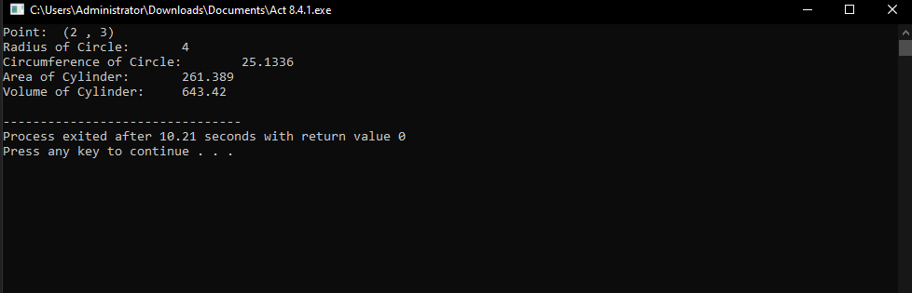

**ACTIVITY 6.3.1:**

**Output:**

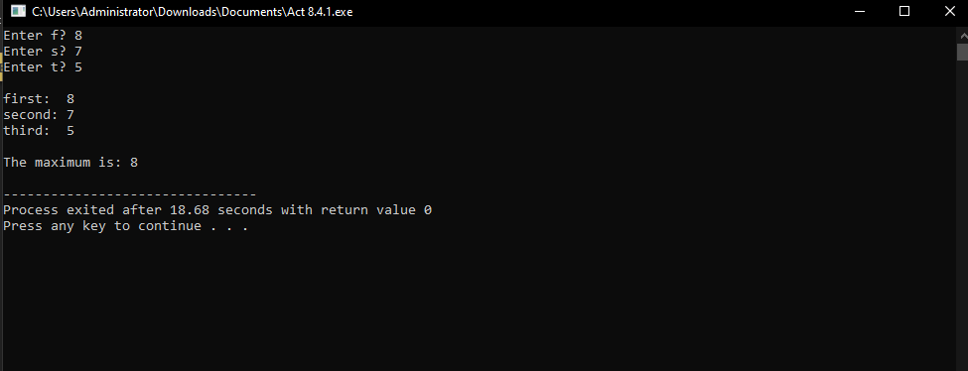

**ACTIVITY 7.4.1:**

**Output:**

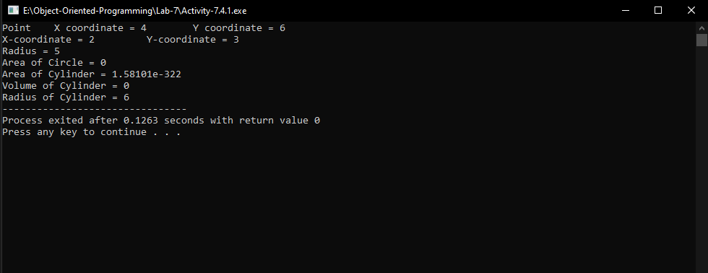

**ACTIVITY 8.4.1:**

**Output:**

